4.50: a)
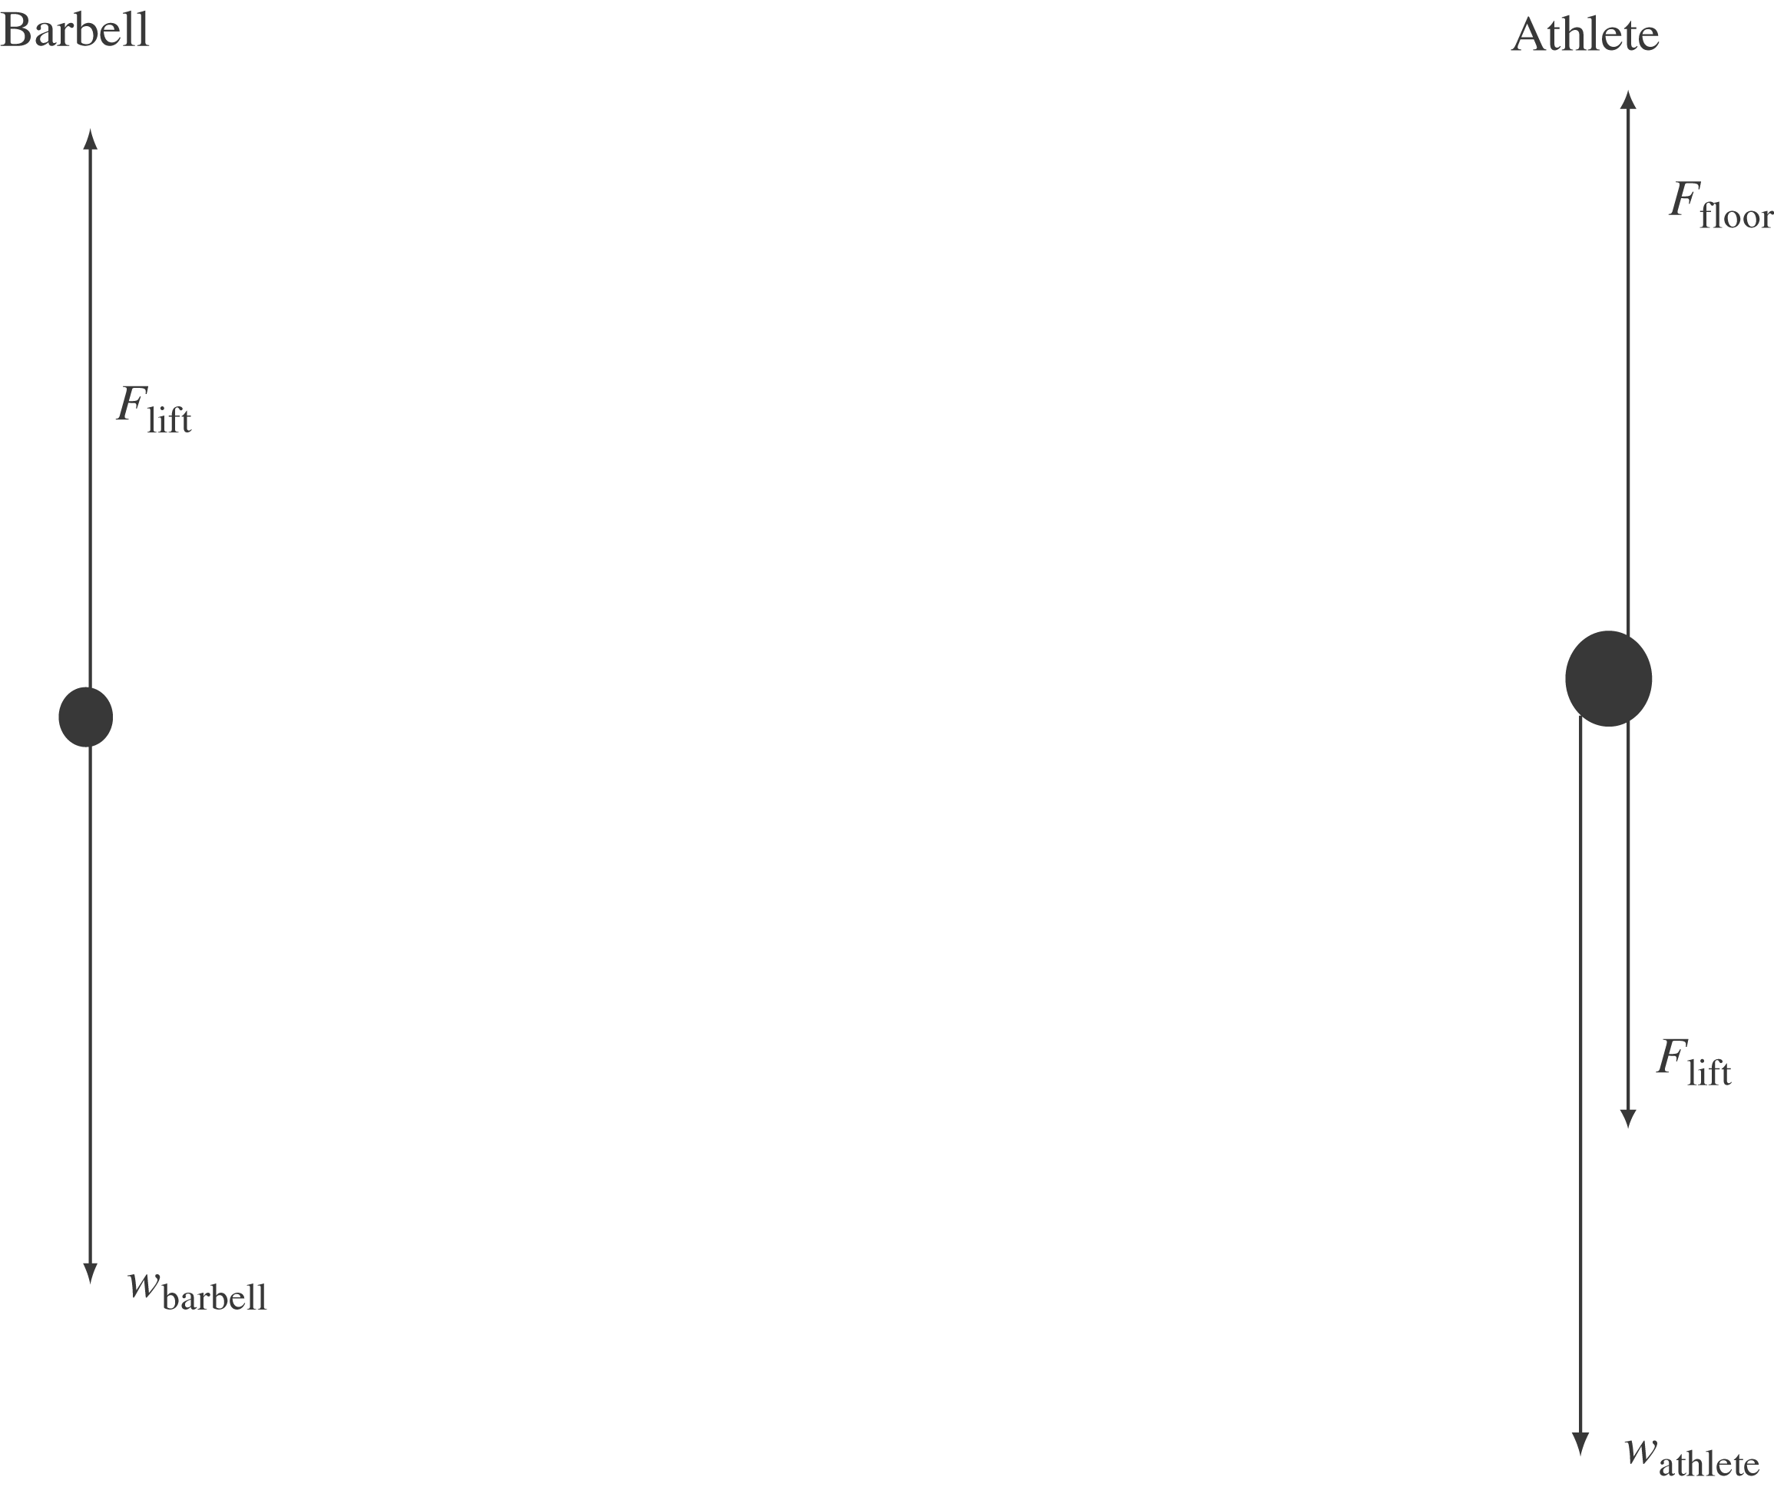

b) The athlete’s weight is 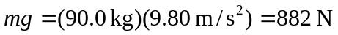. The acceleration of the barbell is found from 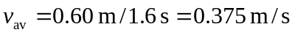. Its final velocity is thus 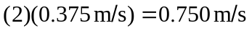, and its acceleration is
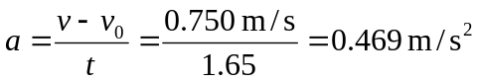
The force needed to lift the barbell is given by:
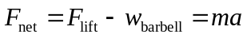
The barbell’s mass is 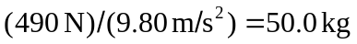, so
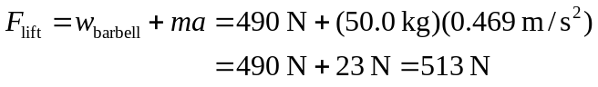
The athlete is not accelerating, so:
